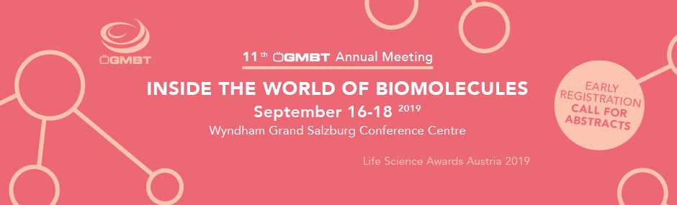

It is our great pleasure to invite you to the 11th ÖGMBT Annual Meeting, which will be held under the title “Inside the World of Biomolecules” - from September 16-18, 2019 in Salzburg, Austria.
This meeting – the largest life science meeting in Austria – connects established scientists, early-career scientists with students and corporate representatives.
The very active and successful life sciences scene in Austria shall become visible in form of talks and posters, for which abstracts are kindly requested. Scientists from all research areas are welcome to attend, as additional poster sessions with open topics will also be held.

REGISTER NOW*
*Be among the first 15 to register and receive an “ÖGMBT 10 years” T-Shirt for free!

…and be part of the annual showcase in the Austrian Life Sciences community!
Early registration until May 9th 2019
PhD students are particularly invited to showcase their work and take the opportunity to start building their professional networks.

For up-to-date information visit: http://www.oegmbt.at/jahrestagung

Main Topics
Epigenetics
Immune Oncology
Immunology and Allergology
Infection Biology
Joint Doctoral Schools: Science Meets Technology
Microbial Interactions and Microbiome
Plant Signaling
Tissue Regeneration and Cell Based Therapies
Translational Oncology
Trends in Development and Manufacturing of Biologics

Invited & Plenary Speakers
Leila Akkari, Netherlands Cancer Institute, NL
Francesco Boccellato, University of Oxford, UK
Guido Boehmelt, Boehringer Ingelheim RCV, AT
Daniel De Carvalho, UHN, CA
Massimo Dominici, Unimore, IT
Claudio Franceschi, University of Bologna, IT
Peter Hegemann, Humboldt University Berlin, DE
Frits Koning, Leiden University, NL
Markus Künzler, ETH Zürich, CH
Alberto Mantovani, Humanitas University, IT
Kim Midwood, University of Oxford, UK
Kevin Ryan, University of Glasgow, UK
Waltraud Schulze, University of Hohenheim, DE

Life Science Awards Austria 2019 – Best Poster & Talk Awards – Exhibitor Quiz – Networking Events

We are very much looking forward to welcoming you at the congress!
Help us spread the word!

On behalf of the committee
Silja Weßler

office@oegmbt.at
http://www.oegmbt.at/jahrestagung
https://www.facebook.com/oegmbt/

